Exponents Practice Test Question Answers
SET: 1
1. Out of the following, the number which is not equal to (– 8/27) is
🔘 A. – (¾)³ | 🔘 B. – (½)³
🔘 C. – (2/3)³ | 🔘 D. (2/3)³
🔘 E. (-2/3)³
Show Answers
2. (-7)⁵ × (-7)³ is equal to
🔘 A. (-7)⁵ | 🔘 B. (7)²
🔘 C. (-7)-⁵ | 🔘 D. 7
🔘 E. (-7)⁸
Show Answers
3. Which one of the following exponential notation of 648?
🔘 A. 3² × 4³ | 🔘 B. 2³ × 3⁴
🔘 C. 3³ × 4⁴ | 🔘 D. 2³ × 4³
🔘 E. 3³ × 3³
Show Answers
4. What is the value of x ? So that
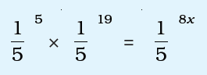
🔘 A. 1 | 🔘 B. 2
🔘 C. 3 | 🔘 D. 4
🔘 E. 5
Show Answers
5. If 2¹⁹⁹⁸ – 2¹⁹⁹⁷ – 2¹⁹⁹⁶ + 2¹⁹⁹⁵ = E2¹⁹⁹⁵ then the value of E is
🔘 A. 1 | 🔘 B. 2
🔘 C. 3 | 🔘 D. 4
🔘 E. 11
Show Answers
6. Which of the following is not equal to 1 ?
🔘 A.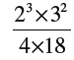 | 🔘 B.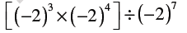
🔘 C.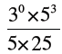 | 🔘 D.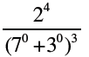
🔘 E. NOTA
Show Answers
7. Choose one of the following answer to make the statements true
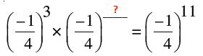
🔘 A. (-1/4)² | 🔘 B. (-1/4)³
🔘 C. (-1/4)⁴ | 🔘 D. (-1/4)⁸
🔘 E. (-1/4)⁹
Show Answers
8. Choose one of the following answer to make the statements true
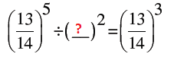
🔘 A. (14/15) | 🔘 B. (13/14)
🔘 C. (13/15) | 🔘 D. (12/13)
🔘 E. (14/16)
Show Answers
9. 340900000 = 3.409 × 10?
🔘 A. 10² | 🔘 B. 10⁴
🔘 C. 10⁸ | 🔘 D. 10¹²
🔘 E. 10¹⁶
Show Answers
10. Find the value of (6/13)¹⁰ ÷ [(6/13)⁵]² = ?
🔘 A. (6/13) | 🔘 B. (6/13)²
🔘 C. (7/13)⁵ | 🔘 D. (3/7)²
🔘 E. (6/11)²
Show Answers

