Lines (Geometry) Practice Test Question Answers

SET-1

1. If two lines are intersected by a transversal, then the number of pairs of interior angles on the same side of
the transversal is
🔘 A. 0 | 🔘 B. 1
🔘 C. 2 | 🔘 D. 3
🔘 E. 4
Answers
2. In the given figure, find out which pair of lines are parallel.
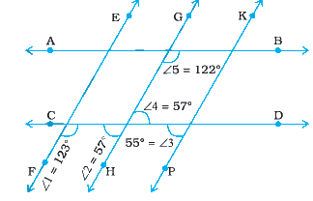
🔘 A. GH || KP | 🔘 B. EF || KP
🔘 C. AB || CD | 🔘 D. EF || GH.
🔘 E. NOTA
Answers

3. In the following lines, l and m intersect each other at a point. Which of the following is false?
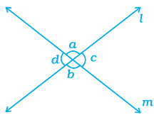
🔘 A. ∠a = ∠b | 🔘 B. ∠d = ∠c
🔘 C. ∠a + ∠d = 180° | 🔘 D. ∠a = ∠d
🔘 E. NOTA
Answers
4. In the following figure POR is a line. The value of a is
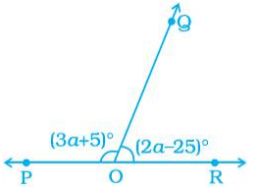
🔘 A. 20° | 🔘 B. 40°
🔘 C. 60° | 🔘 D. 80°
🔘 E. 120°
Answers

5. In the following figure POQ is a line. If x = 30°, then ∠QOR is
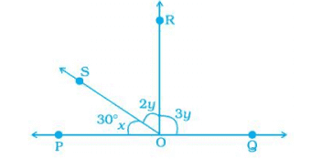
🔘 A. 30° | 🔘 B. 60°
🔘 C. 80° | 🔘 D. 90°
🔘 E. 110°
Answers
6. In the following figure, PA || BC || DT and AB || DC. Then, the values of a and b are respectively.
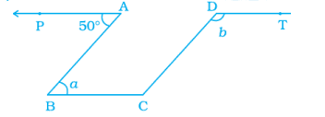
🔘 A. 50°, 130° | 🔘 B. 30°, 120°
🔘 C. 40°, 90° | 🔘 D. 10°, 110°
🔘 E. 30°, 90°
Answers
7. In the following figure, PQ || SR and SP || RQ. Then, angles a and b are respectively
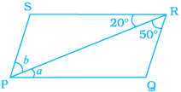
🔘 A. | 🔘 B.
🔘 C. | 🔘 D.
🔘 E.
Answers
8. In the following figure, lines AB and CD intersect at O. If ∠ AOC + ∠ BOE = 70° and ∠ BOD = 40°, find ∠ BOE
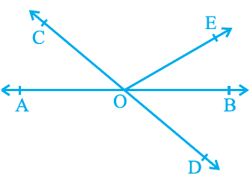
🔘 A. 30° | 🔘 B. 40°
🔘 C. 50° | 🔘 D. 60°
🔘 E. 70°
Answers
9. In the following figure, lines AB and CD intersect at O. If ∠ AOC + ∠ BOE = 70° and ∠ BOD = 40°, find ∠ COE
🔘 A. 60° | 🔘 B. 90°
🔘 C. 150° | 🔘 D. 160°
🔘 E. 250°
Answers
10. In the following figure, lines XY and MN intersect at O. If ∠ POY = 90° and a : b = 2 : 3, find c.
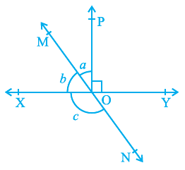
🔘 A. 62° | 🔘 B. 96°
🔘 C. 126° | 🔘 D. 176°
🔘 E. 216°
Answers

