OGET Math Practice Test
Sample Test -1

Q1. Simplify the expression by combine similar terms
8 – 5(6x – 2)8–5(6x–2)
🔘 A. 3 – 12x | 🔘 B. 3 – 28x
🔘 C. 18 – 30x | 🔘 D. 3 – 4x
Show Answers
Q2. Which of the following expressions is equivalent to the expression 17 − 4x for all values of x?
🔘 A. 1 – (2x – 8) | 🔘 B. 3 + (3x – 6)
🔘 C. 5 – (4x – 12) | 🔘 D. 5 + (-6x – 17)
Show Answers
Q3. If \frac3443​ x – 11 = 1 then find the value of x
🔘 A. 2 | 🔘 B. 4
🔘 C. 8 | 🔘 D. 16
Show Answers
Q4. Find the side z is between which two integers in the following figure?
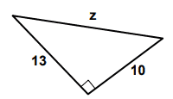
🔘 A. 15 and 16 | 🔘 B. 16 and 17
🔘 C. 18 and 19 | 🔘 D. 20 and 21
Show Answers
Q5. Find the vaule of a
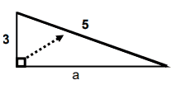
🔘 A. 1 | 🔘 B. 2
🔘 C. 3 | 🔘 D. 4
Show Answers
Q6. James has twice as many coins as Robert. Joseph has 5 more coins than James. If the total number of coins is 50, how many coins does Joseph have?
🔘 A. 23 | 🔘 B. 26
🔘 C. 30 | 🔘 D. 34
Show Answers

Q7. The table shows how many students entered class at different times
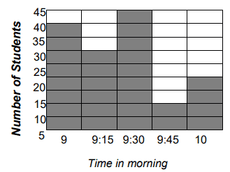
How many students entered class after 9 a.m.?
🔘 A. 80 | 🔘 B. 90
🔘 C. 95 | 🔘 D. 105
Show Answers

Q8. The following graph of line k is shown in the xy-plane above. The point on line k that has x-coordinate 40 is not shown. What is the y-coordinate of that point?
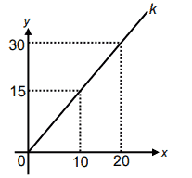
🔘 A. 35 | 🔘 B. 40
🔘 C. 55 | 🔘 D. 60
Show Answers

Q9. What is the length of a diagonal in the following rectangle?
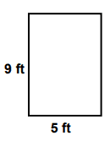
🔘 A. 8.5 ft | 🔘 B. 9.6 ft
🔘 C. 10.3 ft | 🔘 D. 12.9 ft
Show Answers
Q10. Michele sells advertising in a local magazine. She makes $450 per week plus $50 for every new full page ad she sells that week. If she wants to make at least $3000 so she can take a trip to Bali, how many ads will she need to sell?
🔘 A. 25 | 🔘 B. 31
🔘 C. 50 | 🔘 D. 51
Show Answers

