OGET Sample Math Practice Test 2
Q1. Simplify the expression by combine similar terms
4 – (2x + 7)4–(2x+7)
🔘 A. -3 – 2x | 🔘 B. 2 – 9x
🔘 C. -3 + 9x | 🔘 D. 3 + 2x
Show Answers
Q2. If the sum of the numbers in column A is equal to the sum of the numbers in row B, then find the value of Y.
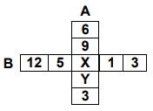
🔘 A. 3 | 🔘 B. 6
🔘 C. 9 | 🔘 D. 16
Show Answers

Q3. Which is the correct graph of the equation: 4x + 3y = 12?
🔘 A.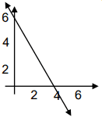 | 🔘 B. 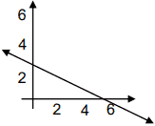
🔘 C. 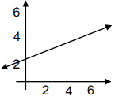 | 🔘 D.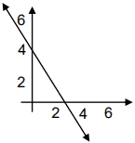
Show Answers
Q4. Rosa deposits $1,600 in her bank. It is all in twenties and tens. If z represents the number of twenty dollar bills, which of the following represents the number of ten dollar bills?
🔘 A. 1000 – 10z / 3 | 🔘 B. 1200 – 10z / 5
🔘 C. 1600 – 20z / 10 | 🔘 D. 1900 – 6z / 2
Show Answers
Q5. A 50 ft. ladder is leaning up against a wall as shown below. If the ladder slips down the wall 8 feet, how much further will the base of the ladder now be from the wall?
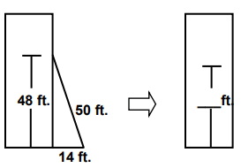
🔘 A. 4 feet | 🔘 B. 8 feet
🔘 C. 16 feet | 🔘 D. 20 feet
Show Answers
Q6. A rectangular box has a base that is a rectangle with width 5 in. and length 10 in. If the volume of the box is 975 cubic inches, what is the height of the box?
🔘 A. 13.6 | 🔘 B. 17.3
🔘 C. 17.7 | 🔘 D. 19.5
Show Answers
Q7. A company has 16 million dollars in total expenses for one year. A circle graph shows a sector of 270 degrees representing employee salaries. How much was spent on employee salaries?
🔘 A. 10 million | 🔘 B. 11 million
🔘 C. 12 million | 🔘 D. 13 million
Show Answers
Q8. If k + m = 53 and j + p = 20, what is the value of (5k + 5m)(2j + 2p)?
🔘 A. 160 | 🔘 B. 1060
🔘 C. 10.6 | 🔘 D. 10600
Show Answers
Q9. The graph of a linear equation is shown below. Which of the following tables corresponds to the graph?
🔘 A.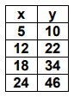 | 🔘 B. 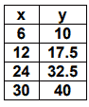
🔘 C. 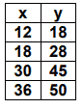 | 🔘 D.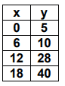
Show Answers
Q10. We all know that the more time we spend studying for a test the higher our test score will be. Which of the following graphs could be the graph of the relationship between time studying and score on the CORE test?
🔘 A.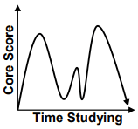 | 🔘 B. 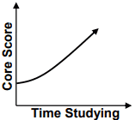
🔘 C. 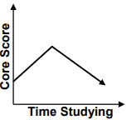 | 🔘 D.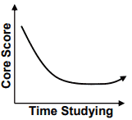
Show Answers

