ASVAB Auto and Shop Information Practice Test

1. If you hear a loud clanking noise from the rear of a rear-wheel-drive, front-engine car, you should look for trouble at
- A. the differential or driveshaft.
- B. the transmission.
- C. the engine.
- D. the clutch.
Answer _____
2. If one engine cylinder does not work right, you should check for problems in the
- A. drive train.
- B. pollution controls.
- C. ignition or fuel system.
- D. clutch.
Answer _____
3. If tire pressure gets low, what will happen?
- A. The tire will lose its shape and create extra friction, reducing gas mileage and possibly overheating the tire.
- B. The tire will not absorb energy from the engine.
- C. Vehicle weight will be reduced.
- D. The tire will get better traction on the highway.
Answer _____

4. If an engine with conventional ignition runs rough, what might you adjust on the breaker points, shown as part B of this diagram?
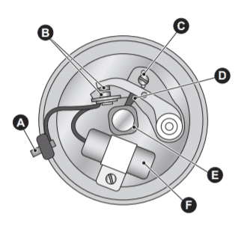
- A. The gap
- B. The timing
- C. Composition
- D. Lubrication
Answer _____

5. One important difference between front-wheel drive and rear-wheel drive is that in front-wheel drive,
- A. the layshaft moves the driveshaft.
- B. the engine must be rotated 180° from the normal position.
- C. the driving wheels also steer.
- D. the rear wheels must also drive.
Answer _____
6. Which is the correct sequence in a four-cycle internal-combustion engine?
- A. Intake, compression, power, rest
- B. Reduction, power, compression, exhaust
- C. Intake, compression, power, exhaust
- D. Exhaust, compression, intake, power
Answer _____
7. If you suspect that not enough gasoline is entering the engine, what might you check first?
- A. Fuel system
- B. Ignition system
- C. Timing belt
- D. Engine control module
Answer _____

8. When a manual transmission is in a “direct-drive” gear, one revolution of the engine produces
- A. two revolutions of the driveshaft.
- B. one revolution of the driveshaft.
- C. one-half revolution of the driveshaft.
- D. two revolutions of the clutch.
Answer _____

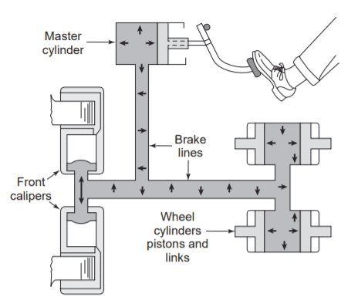
9. In the diagram above, the arrows indicate
- A. viscosity.
- B. brake fluid.
- C. pressure.
- D. temperature.
Answer _____
10. What must happen before the starter motor is engaged?
- A. The brakes must be adjusted.
- B. The starter relay must be closed.
- C. The gas tank must be full.
- D. The oil pump must be automatically primed.
Answer _____
11. If the exhaust valve does not open,
- A. the fuel-air mix cannot enter the engine.
- B. the car will not pollute.
- C. the engine will run a bit rough.
- D. burned gas cannot leave the cylinder, and the engine will not run.
Answer _____
12. If the differential ratio is 3 to 1,
- A. one turn of the driveshaft produces three turns of the wheels.
- B. three turns of the jack shaft produce one turn of the wheels.
- C. the ring gear is probably disengaged.
- D. three turns of the driveshaft produce one turn of the wheels.
Answer _____
13. When choosing a slot screwdriver,
- A. use a blade that slips easily into the slot.
- B. make the blade as wide as the screw head.
- C. always use the shortest possible handle.
- D. file out the screw to fit the screwdriver.
Answer _____
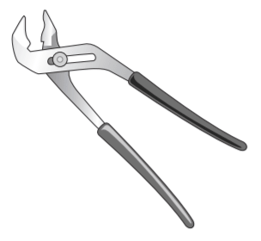
14. The tool shown above is a(n)
- A. locking pliers (Vise Grips).
- B. arc-joint pliers (Channel Locks).
- C. monkey wrench.
- D. side-cutting electrician’s pliers.
Answer _____
15. A plywood-cutting blade for a circular saw
- A. has a few big teeth because plywood is so much harder than regular wood.
- B. cannot be used with particle board.
- C. must not be too sharp or else it will burn the wood.
- D. has many small teeth, to reduce splintering.
Answer _____
16. Which of the following is a poor use for a claw hammer?
- A. Pulling nails
- B. Hammering nails
- C. Driving screws
- D. Driving wood chisels
Answer _____
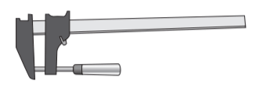
17. The tool shown above is used for
- A. clamping parts for gluing.
- B. tightening large pipe fittings.
- C. pressing a drill into the chuck.
- D. pressing glass into a window sash.
Answer _____
18. It helps to hit a larger chisel with a bigger hammer because the hammer is
- A. heavier.
- B. more massive.
- C. bigger, and therefore less likely to miss the chisel.
- D. slower-moving.
Answer _____

19. Plywood is better than regular wood for a subfloor mainly because
- A. it is more weatherproof.
- B. it is lighter.
- C. it is thinner.
- D. it is stronger.
Answer _____

20. Which tool might replace a hacksaw for some jobs?
- A. A circular saw with a carbide blade
- B. A keyhole saw
- C. A coping saw
- D. An oxyacetylene cutting torch
Answer _____
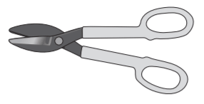
21. The tool shown above is a
- A. tin snip.
- B. magna-shear.
- C. bolt cutter.
- D. duckbill wrench.
Answer _____
22. Which of these tools does not start to clamp until you turn it?
- A. C-clamp
- B. Locking pliers
- C. Pipe wrench
- D. Vise
Answer _____
23. What is not an advantage of a sharp drill bit?
- A. It creates a smaller amount of chips.
- B. It cuts with less pressure.
- C. It cuts cooler.
- D. It cuts faster.
Answer _____
24. Which of the following would not loosen a frozen nut?
- A. Heating it with a torch
- B. Pounding it with a hammer
- C. Soaking it in penetrating oil
- D. Dousing it in ice water
Answer _____
25. A plumb line makes what kind of angle where it intersects a level line?
- A. Acute
- B. Obtuse
- C. Square
- D. Straight
Answer _____
Answer Keys and Explanation
https://gotestprep.com/asvab-auto-and-shop-practice-test/

