ASVAB Mathematics Knowledge Practice Test

Q1. x + 9 = 13, Find x = ?
- A. 3
- B. 4
- C. 5
- D. 13
Answer __
Q2. 3² + 4(5 – 2) = ?
- A. 21
- B. 36
- C. 39
- D. 40
Answer __
Q3. 1 \frac14 × 2 \frac12 = ?141​×221​=?
- A. 2 \frac12221​
- B. 2 \frac14241​
- C. 2\frac34243​
- D. 3 \frac18381​
Answer __
Q4. The square root of 64 =
- A. 4
- B. −8
- C. 9
- D. −9
Answer __
Q5. . What is the value of the following expression if x = 2 and y = 4?
2x³y²
- A. 52
- B. 106
- C. 256
- D. 512
Answer __
Q6. Add:
3x² + 3xy + 4y + 2y²
3x² + xy + 9y + y²
−5x² − 2xy − 13y + y²
−3x² + 3xy + y − 4y
- A. 2x + xy + 2y + y²
- B. − 2x − xy + y + y²
- C. −3x² − 2xy − 3y + y²
- D. −2x² + 5xy + y
Answer __
Q7. Factor the following expression: y² − 16y + 48
- A. (y − 1)(y +48)
- B. (y − 4)(y − 12)
- C. (y − 4)(y + 4)
- D. (y +1)(y − 16)
Answer __

Q8. Solve for x. 12x + 6 = 8x +10
- A. x = 1
- B. x = 2
- C. x = 4
- D. x = 6
Answer __
Q9. Solve for the two unknowns.
3y + 3x = 24
6y + 3x = 39
- A. y = 3; x = 5
- B. y = 4; x = 6
- C. y = 5; x = 3
- D. y = 6; x = 2
Answer __
Q10. x¹² / x⁴
- A. x⁻⁴
- B. x⁸
- C. x¹⁸
- D. x⁻¹⁶
Answer __
Q11. Solve for y.
y² + 7y = −10
- A. y = −5; y = −2
- B. y = 1; y = −10
- C. y = −2; y = 6
- D. y = 5; y = −1
Answer __
Q12. Multiply: \frac{6y}{11} × \frac{2}{5x}116y​×5x2​
- A. 6y + 5x =22
- B. 22y / 5x
- C. 5y/ 22x
- D. 22y / 55x
Answer __
Q13. Divide: \frac{6x}{11} ÷ \frac{2}{5y}116x​÷5y2​
- A. 3y + 11x =2
- B. 15xy / 11
- C. 12/ 22xy
- D. 11y / 25x
Answer __
Q14. \sqrt[3]2732​7
- A. 3
- B. 4
- C. 5
- D. 2.25
Answer __
To answer most questions of this type on the ASVAB, you just need to memorize some basic cubes. It would be wise to memorize all the
cubes from 2 to 10, just to prepare for ASVAB test item possibilities
Q15. Solve for g \fracgh =a\fracgh=a
- A. ga / h
- B. g =a/h
- C. g = ah
- D. g = a ÷ h
Answer __

Q16. Which of the following is an equilateral triangle?
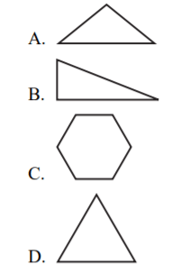
Answer __
Q17. What is the perimeter of the following rectangle?
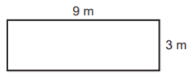
- A. 12 m
- B. 18 m
- C. 24 m
- D. 12 m
Answer __

Q18. What is the circumference of the following circle?
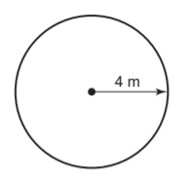
- A. 6.56 m
- B. 12.56 m
- C. 25.12 m
- D. 35.12 m
Answer __
Q19. In the following equilateral triangle, what is the measure of ∠1?
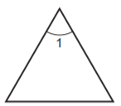
- A. 30°
- B. 45°
- C. 60°
- D. 90°
Answer __
20. If ∠1 is 34°, what is the measure of ∠2?
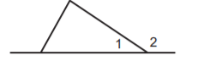
- A. 56°
- B. 110°
- C. 146°
- D. 180°
Answer __
Q21. In the following right triangle, what is the length of side AB?
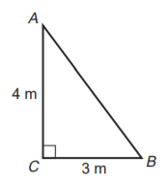
- A. 3 m
- B. 5 m
- C. 7 m
- D. 12 m
Answer __
Q22. What is the area of the following triangle?
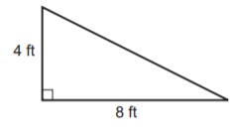
- A. 8 ft²
- B. 12 ft²
- C. 15 ft²
- D. 16 ft²
Answer __
Q23. What is the diameter of the following circle?
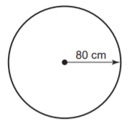
- A. 40 cm
- B. 80 cm
- C. 160 cm
- D. 640 cm
Answer __
Q24. If lines A and B are parallel and are intersected by line C and ∠2 is 30°, what is the measure of ∠7?
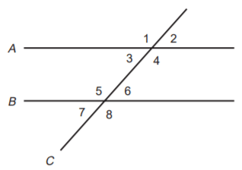
- A. 30°
- B. 50°
- C. 112°
- D. 130°
Answer __
Q25. What is the volume of a cylinder with a height of 15 m and a radius of 5 m?
- A. 235.50 m³
- B. 1,177.50 m³
- C. 1,280.25 m³
- D. 1,340.25 m³
Answer __

Answers Keys and Explanation Link
https://gotestprep.com/asvab-math-practice-test-pdf/

