TABE Reading Practice Test

Here is an excerpt from a work procedure at a manufacturing firm. Read the document and then answer Questions 6 through 10.
ABC Inc.
Manufacturing Engineering Procedures
The purpose of this procedure is to document methods ABC Inc. uses to control manufacturing processes. The procedure applies to ABC Inc. documents used at any of ABC Inc.’s facilities. Responsibility
The Industrial Engineering Supervisor is responsible for the maintenance, interpretation, and implementation of this policy/procedure. It is the responsibility of all ABC Inc. supervisors and managers to enforce the use of this policy/procedure.
Procedure
Location—Shop Floor
- 1.1 Product drawings will be filed in a centrally located cabinet.The machine operator will assure that the drawing number and revisions match the shop order prior to running the job. If a new drawing is required, the operator shall notify the department supervisor.
- 1.2 Process, test, inspection and set-up instructions will be available to production either electronically via the ABC Inc. Intranet or through paper documents kept in binders in the department they are used in.
- 1.3 The supervisor or lead person can print out electronic documents from their local printer or paper documents may be removed from the binder they are stored in. Under no circumstances should documentation remain at workstations after the process defined in the documents has been completed. Paper documents must be returned to their proper location and any electronic document should be destroyed after it has been used.
- 1.4 Any drawings used on the manufacturing floor must be logged out at the central file to identify the drawing, revision, and location of the document.
It is the department supervisor’s responsibility to assure these drawings maintain the current revision.
Q1. The purpose of this document is to
- A. Provide information about engineering
- B. Explain ABC Inc.’s business
- C. Outline the methods used to control manufacturing processes
- D. Explain where documents are kept
Answer : ____

Q2. In the purpose statement at the beginning of this document, the word processes means
- A. Policies
- B. Products
- C. Operations
- D. Inspections
Answer : ____

Q3. Who is responsible for enforcing this policy/procedure?
- A. The department supervisor
- B. The industrial engineering supervisor
- C. All ABC Inc. employees
- D. All managers and supervisors
Answer : ____

Q4. What should be done with used electronic documents?
- A Print them out
- B Remove them from the binder
- C Destroy them
- D Remain at the workstation
Answer : ____

Q5. Who should make sure the drawings are kept current?
- A. The lead person
- B. The supervisors and managers
- C. The department supervisor
- D. The Industrial Engineering Supervisor
Answer : ____

After you read this advertisement, answer Questions 6–9.
Secretary Wanted: Busy Office
Must be able to word process 80 words per minute, take dictation, know Microsoft Word and Excel, and keep files up-to-date. Important: Person must know how to greet and direct clients and handle inquiries and requests of incoming phone calls.

Q6. Which of the following is a correct inference based on the job advertisement?
- A. The new employee will answer the telephone and keep files organized.
- B. The new employee will take dictation, but not have to word process.
- C. The new employee must be comfortable handling more than one task at a time.
- D. The new employee can plan on a one-week vacation after the first year’s employment.
Answer : ____

Q7. In this advertisement, the word inquiries means
- A. Incoming messages
- B. Requests
- C. Incoming questions
- D. Quirks
Answer : ____

Q8. One of the computer applications the new employee must know is
- A. PowerPoint
- B. Algebra
- C. Freelance
- D. Microsoft Word
Answer : ____

Q9. You can tell the main idea of this advertisement by
- A. Looking at the heading
- B. Reading the first half of the first sentence
- C. Knowing who applied for the job
- D. Writing an application and cover letter
Answer : ____

Read this letter and answer Questions 10 through 14.

Cal Meinhard, President
Insurance Services of America
10 Afton Boulevard
Hartford, CT 00000
Dear Senator Ross:
A vote is coming up on increasing the funds for Worksite Training, and I am writing to ask you to cast a positive vote. Many factors, including economic, social, and technological, argue in favor of increased worksite training.We have moved to an information age of high technology, global competition, and a multicultural workforce. All of these changes require upgraded employee skills.
Although we are still concerned with graduating students who can read, write, and use math skills, we know now that there are job/work specific skills that need to be addressed.We need to work together to define those skills and implement the training. As a start, we should concern ourselves with employees’ ability to value different cultures in the workplace. Inherent here are implications for teamwork as well. In addition, because of the automation of technology, our entry-level workers have to make decisions, use critical thinking skills, and work with much less supervision. Finally, Senator, we must do a better job of bringing the workplace together with the schools—public, technical, and advanced—to ensure that our newest employees benefit from all of our experiences. Please vote for the bill.
Very truly yours,
Cal Meinhard
Q10. The reader can easily tell what this letter is going to be about because
- A. The letter was written by a businessperson to a senator.
- B. The letter talks about how industry wants an additional million dollars for programs.
- C. The letter works because it uses humor to make a point.
- D. The topic is introduced in the first sentence.
Answer : ____

Q11. In the second paragraph of the letter, the opposite of the word inherent is
- A. Included
- B. Inherited
- C. Excluded
- D. Invited
Answer : ____

Q12. You can infer from what you have read that Mr. Meinhard needs employees who can
- A. Devote more hours to a longer workweek
- B. Work independently
- C. Use technology in their jobs
- D. B and C above
Answer : ____

Q13. According to this letter, employees need to work on
- A. Getting to work on time
- B. The Internet
- C. Valuing different cultures
- D. Thinking less, doing more
Answer : ____

Q14. You could say that this letter’s purpose is to
- A. Entertain
- B. Persuade
- C. Interrogate
- D. Insult
Answer : ____

Telephone message forms seem like simple items. In fact, they can include essential ideas, details, and inferences that require reading skill.
Read the messages below and answer Questions 15 to 20.
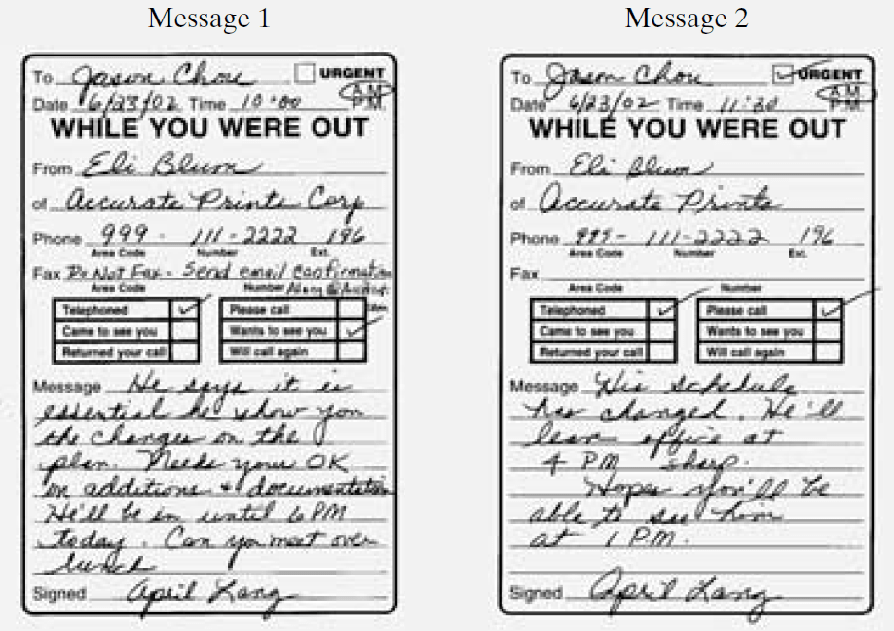
Q15. Look at the words “email confirmation” in Message 1.What does this mean?
- A. Say yes by e-mail.
- B. Phone me if you can come.
- C. Do not reply by fax.
- D. Phone me if you can’t come.
Answer : ____

Q16. Jason Chou has two messages from Eli Blum. Which one is more urgent?
- A. Message 1 is more urgent because it arrived first.
- B. Message 1 is more urgent because it requests lunch at 12 noon sharp.
- C. Message 2 is more urgent because the caller will be leaving the office shortly.
- D. Message 2 is more urgent because the caller will be leaving earlier than he first said.
Answer : ____

Q17. What is the first clue to the urgency of the message?
- A. The caller’s name
- B. The time of the call
- C. The Urgent box is checked
- D. The date of the call
Answer : ____

Q18. You can conclude that Eli Blum’s first choice is to
- A. Meet and work over lunch
- B. See Jason at 4 P.M.
- C. Meet Jason at 6 P.M.
- D. Cancel his request
Answer : ____

Q19. In Message 1, the caller has asked Jason
- A. To please fax instead of calling back
- B. To fax and call him
- C. To fax, call, and e-mail
- D. Not to use the caller’s fax
Answer : ____

Q20. You can infer from the two messages that Eli wants to see Jason
- A. No later than a week from now. There’s plenty of time.
- B. No earlier than 9:30 A.M. He’s sleeping late.
- C. No later than today. He needs Jason’s input in order to go forward.
- D. No earlier than 2003. He wants to delay the project for as long as possible.
Answer : ____

Answer Keys Link
https://gotestprep.com/tabe-reading-practice-test/

